**Software Project Management Plans**

{AlgorithmA}; 2010

**Winter 2010**



CS455 Inc.

CEO: Dr. Concepcion

Project Manager: Patrick O’Connor

Assistant Managers: Danny Vargas and Abdelrahman Kamel

**Table of Contents**

1. **Overview** 
   1. **Project Summary**
   2. **Assumptions and Constraints**
   3. **Project Deliverables**
   4. **Projection and Budget Summary**
   5. **Evolution of the SPMP**
2. **Vague Definitions**
3. **Project Organization** 
   1. **External Interfaces**
   2. **Internal Structure**
   3. **Roles and Responsibilities**
4. **Managerial Process Plans** 
   1. **Project Start‐up Plan** 
      1. **Estimation Plan**
      2. **Staffing Plan**
      3. **Resource Acquisition Plan**
      4. **Project Staff Training Plan**
5. **Work Plan** 
   1. **Work Activities**
   2. **Scheduling Allocation**
   3. **Resource Allocation**
6. **Control Plan** 
   1. **Requirements Control Plan**
   2. **Schedule Control Plan**
   3. **Quality Control Plan**
   4. **Reporting Plan**
   5. **Metrics Collection Plan**
7. **Risk Management Plan** 
   1. **Product Risk Plan**
8. **Project Closeout Plan**
9. **Infrastructure Plan**
10. **Product Acceptance Plan**
11. **Supporting Process Plans** 
    1. **Configuration Management Plan**
    2. **Verification and Validation Plan**
    3. **Documentation Plan**
    4. **Quality Assurance Plan**
    5. **Reviews and Audits Plan**
    6. **Problem Resolution Plan**
    7. **Process Improvement Plan**

**1. Overview**

**1.1 Project Summary**

AlgorithmA 2010 will be transforming the previous Java code to a new programming platform using JavaScript. By doing this shift from Java to JavaScript we can implement more animation with little difficultly and more control over the animations. Porting of the code will also be done with low level of coupling and high level of cohesion so that the animations are highly efficient. Per the request of the CEO there will be only thirteen animations implemented in the new JavaScript language.

**1.2 Assumptions and Constraints**

The foundation of AlgorithmA 2010 will be based on the current foundation of AlgorithmA 2009. The web layout might change depending how the upcoming animations might look. The main interface to the website will however stay the same. The project will build upon the current foundation alongside fixing major faulty features and inconsistencies found throughout the project.

The schedule of the project will be confined to the duration of the Winter Quarter of 2010. All scheduled deadlines will be made between the present time to the conclusion of the project. The conclusion of the project will be demonstrated in a presentation on the time of finals week of Winter 2010 Quarter of CSUSB.

**1.3 Project Deliverables**

**SRS** ‐ The Software Requirement Specification is the document that details the specifications of the project.

**SQAP** ‐ The Software Quality Assurance Plan is the document by which the progress of the project development is defined and measured.

**Architecture** ‐ The overall architecture for the project, defined by a class diagram.

**Team Detailed Design** ‐ The team‐developed, detailed architecture that enumerates the details of their portion of the project with inclusion of class diagrams.

**Unit Test** ‐ The code test plan that each team will use prior to integration.

**Integration Test Plans** ‐ The plan that is utilized to ensure that modules both function together properly and satisfy the key project specifications.

**Team Integration** ‐ The compilation of the separate components of the project by each team member.

**System Integration** ‐ The compilation of the separate components of the project by each team.

**Documented Source Code** ‐ The source code should have proper documentation to aid with future additions and maintenance.

**Maintenance Manual** ‐ The document which describes the modifications made during the maintenance of AlgorithmA 2010.

**Bug Reports** – The bug reporting database (BugZilla) has been cleared for AlgorithmA 2010. A clean report that details the bugs found solely in AlgorithmA 2010 will be provided as a deliverable. Bugs found in the database will be ranked on a 0‐5 scale based on level of severity.

**Deployment Diagram** – The deployment diagram will outline the specific system interfaces utilized by AlgorithmA 2010, and the hardware and software specifications for use of AlgorithmA 2010. Refer to the 2010 SRS for more information.

**Project Review** – This document will contain all the specifics of what and how the teams accomplished during their work on AlgorithmA 2010. The purpose of the Project Review is to aid future AlgorithmA project teams by documenting what the AlgorithmA 2010 team did, how they did it, and why they did it.

**Corrections to Hard‐Coded Pseudocode (Walkthroughs)** – The pseudocode listed on the walkthroughs must undergo correction to ensure compliance with the syntax of “AL” pseudocode.

**1.4 Projection and Budget Summary**

As stated earlier, the schedule for AlgorithmA 2010 will be confined to the duration of Winter Quarter of 2010. The management team will schedule all project deliverables around this time confinement.

This project features no budget whatsoever, since the project is being completed with no monetary funds. In addition, the members of the project team are not working under a salary. Therefore, no funds are necessary to complete this project.

**1.4 Evolution of the SPMP**

The management team will handle any and all unscheduled updates to the SPMP. Unscheduled updates will occur in the event that any outlined clause in the SPMP violates or conflicts with the plan or execution of AlgorithmA 2010. This iteration of the SPMP will be implemented, and any faults present will be noted and addressed in the next iteration of the project.

**2 Vague Definitions**

**MVC** – A design pattern that is used in creating software architecture. The components are Model, View, and Controller.

**Walkthrough** ‐ A step‐by‐step guided tour through an algorithm. Every step highlights the current line and displayed pseudo‐code for the algorithm while displaying a graphical representation of components that are affected by the algorithm.

**SVN (SubVersion)** – Application used to store data repositories. Used for large projects.

**3 Project Organization**

Information presented here will cross‐reference that which is presented in section 3 of the SQAP and those that are found throughout the SRS. Refer to those documents for additional information.

**3.1 External Interfaces**

All communication with the CEO will be through the project manager. If the project manager is absent or unable to communicate with the CEO, the designated Assistant Project Managers shall fulfill this role.

**3.2 Internal Structure**

The following is a listing of the organization of the members of the project team for work on the AlgorithmA 2010 project:

**CEO:**

* Dr. Concepcion

**Project Manager:**

* Patrick O’Connor

**Assistant Managers:**

* Abdelrahman Kamel
* Danny Vargas

**Programming Team A:**

* Evan Plett
* Tim Herr
* Roddy Nguyen
* Derrick Keith
* Mark Mata

**Programming Team B:**

* Gerren Willis
* Justin Catrambone
* David Sturgeon
* Martin Smith
* Manuel Mendez
* Victor Herrera

**Documentation Team:**

* Erick Behr
* Kathleen Daugherty
* Charles Korman
* Tyler Cannon

**Server Team:**

* Neil Banerjee
* Marlo Aragon

**Team Leads:**

* Neil Banerjee (Server team)
* Erick Behr (Documentation team)
* Evan Plett (Programming team A)
* 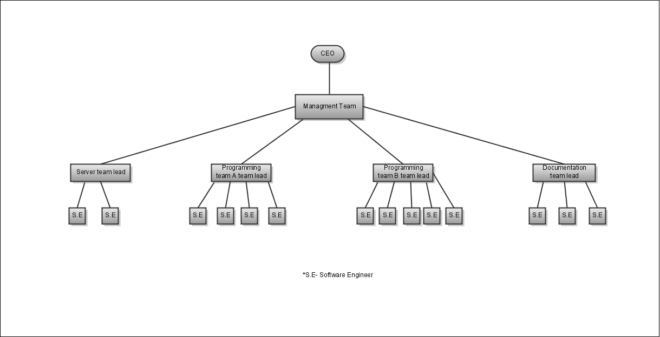Gerren Willis (Porgramming team B)

**3.3 Roles and Responsibilities**

The management team's responsibilities include:

‐‐Constructing the final build of the AlgorithmA project, this includes integration of all products of each team

‐‐Allowing for efficient communication between all team members of the project team. The team leaders will serve as the main contact for each team, and team members are urged to speak to their appropriate team leader. However, software engineers are not limited to only communicating through the team leaders. Open communication will always be encouraged during this project, and team members can talk to the manager in charge of their team if need be.

‐‐Creating and overseeing a schedule that results in the on time delivery of a quality product that satisfies all the requirements described in the SRS.

‐‐Overseeing and supervising each team’s progress throughout the project. The project manager will be responsible for supervising the management team, ensuring that the managers keep to the adopted project schedule. Each manager will be responsible for delegating the work to his two teams in order to complete the tasks required to fulfill the project schedule and comply with the SRS.

‐‐Creating the overall implementation design for AlgorithmA 2010 and oversee its integration into the existing code of the project. AlgorithmA 2010 will implement new features, as well as improve old features using JavaScript, as described in the SRS.

**Programming Team A & B Leadership Roles:**

* Assigns algorithm segments to be ported
* Oversees porting process and documentation
* Reviews submitted code and documentation and make modifications accordingly
* Either approves or disapproves of submissions and forwards appropriately
* Act as support for associated team members
* Collaborate with Architecture team to ensure that produced work meets specifications

**Programming Team A & B Member Roles:**

* Review old algorithms
* Light documentation and thorough understanding of old algorithms
* Port old algorithm to new MVC based architecture
* Heavy documentation of new code
* Submission of code and complete documentation

**Server Team Member Roles:**

* Organize Repositories
* Maintain and Upkeep Servers
* Send necessary notifications
* Maintain open availability to ensure that servers and project functionality maintain in progress
* Learn SubVersion
* Carry out various server related roles

**Documentation Team Leadership Roles:**

* Oversee the progress of the team
* Check all documentation before they are published
* Carry out assigned tasks from Management team
* Works directly with management to ensure that CEO’s requirements are being met.
* Organizes documentation and delivers it to management for final review and modification
* Prepares and delivers output produced and delivered by all teams

**Documentation Team Member Roles:**

* Document high level architecture and forward work to team lead
* Oversee and develop the high level documentation for all the JavaScript Code that will be produced
* Work closely with both programming teams to produce on documentation
* Help eliminate redundancy of any documentation

**4 Managerial Process Plans**

The managerial process that will be implemented in Algorithma 2010 This process outlines how the testing, implementation, design, and analysis procedures are to be implemented. The management team’s task is to ensure that the deliverables are delivered, complete and on time, to the CEO, Dr. Concepcion. The CEO will be provided with a complete repository after the software is complete. The repository will be given to the CEO only with approval from the management team, to ensure that a completed repository is given. To complete this task, the management team must make sure that all teams are communicating properly. In order to keep clear communication between all teams, status reports are to be filed twice a week, Monday and Wednesday, detailing the specific team’s progress. These progress reports are to be completed by the team leaders and submitted to the team managers on the specified dates. The team managers are to correlate all status reports into a single report, which is to be submitted to the project manager for further review. The project manager will take this information and report all relevant information to the CEO.

**4.1 Project Start up Plan**

This section will define the estimation plan, staffing plan, resource acquisition plan, and training plan. Depending on the size and scope of the project, these plans may be incorporated directly or by reference to other plans.

**4.1.1 Estimation Plan**

In the case of a re‐estimation the management team shall meet and decide on the best course of action to resolve the current problem. Time estimations for the software product will be produced in phases and set by the Management team. Each estimation will be based on the percentage of work completed versus the percentage of work to be done. Each manager will report time estimation for each task at the start of the business day.

**4.1.2 Staffing Plan**

Staffing is to be decided within first week of project orientation. This staffing arrangement is to last until the end of the project phase of the software life cycle.

The following table lists the distribution of team members in the different teams comprising the project group for AlgorithmA 2010:

|  |  |
| --- | --- |
| CEO | 1 |
| Management | 3 |
| Programming Team A | 5 |
| Programming Team B | 6 |
| Server Team | 2 |
| Documentation Team | 4 |

**4.1.3 Resource Acquisition Plan**

The resources necessary to develop AlgorithmA 2010 are the responsibility of the Management team and the CEO. The systems administrator of the Department of Computer Science will acquire the hardware necessary for the new AlgorithmA 2010 servers. It is the responsibility of the Server team to ensure the correct functionality of said aforementioned hardware. CSUSB will have all computer labs available for use in order to develop the AlgorithmA 2010 software product. The software required for development is the responsibility of the respective team leaders and managers.

**4.1.4 Project Staff Training Plan**

Training in JavaScript, SVN, Eclipse NetBeans, and Wiki has been arranged, and will take place as needed during the first portion of the Winter Quarter of 2010. The training will primarily be held during designated lab hours on Mondays and Wednesdays by means of demonstration. In addition, personal guidance from management is available.

**5 Work Plan**

This section will clearly define the work activities, schedule, and resources for the AlgorithmA 2010 project.

**5.1.1 Work Activities**

Each of the teams of the AlgorithmA project has specific tasks they will carry out for the course of the project.

The Management team's tasks include:

* Allowing for efficient communication between all team members of the project team. Team members are to obey the hierarchical structure of communication as depicted previously. This allows for a streamlined approach in obtaining information that is necessary to the successful completion of current project objectives.
* Creating and overseeing a schedule that results in the on time delivery of a quality product that satisfies all the requirements described in the SRS.
* Overseeing and supervising each team’s progress throughout the project. The Management team will work as a single body that delegates and oversees tasks that are assigned to subsequent project teams.
* Creating the overall implementation design for AlgorithmA 2010 and oversee its integration into the existing code of the project. AlgorithmA 2010 will implement new features, as well as improve old features, as described in the SRS.

**5.1.2 Scheduling Allocation**

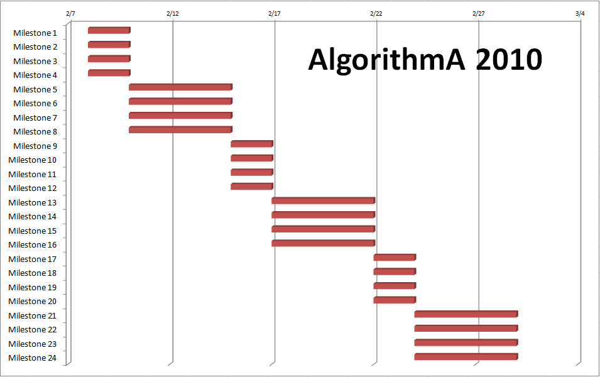

|  |  |
| --- | --- |
| Milestone | Task Description |
| Milestone 1 | Programming Team A: Research current implementation, report bugs. |
| Milestone 2 | Programming Team B: Research current implementation, report bugs. |
| Milestone 3 | Server Team: Initial server setup, report bugs. |
| Milestone 4 | Documentation Team: Locate current wiki documentation, update wiki. |
| Milestone 5 | Programming Team A: Research Javascript, produce initial prototype. |
| Milestone 6 | Programming Team B: Research Javascript, produce initial prototype. |
| Milestone 7 | Server Team: Create backup script, configure/distribute SVN accounts. |
| Milestone 8 | Documentation Team: Update website, adjust to make current. |
| Milestone 9 | Programming Team A: Produce animations for 2 sort algorithms. |
| Milestone 10 | Programming Team B: Produce animations for 3 search algorithms. |
| Milestone 11 | Server Team: Create new repositories, enable live sync SVN -> Web. |
| Milestone 12 | Documentation Team: Diagram/update current system architecture. |
| Milestone 13 | Programming Team A: Completion of 4 sort algorithms. |
| Milestone 14 | Programming Team B: Completion of 5 search algorithms. |
| Milestone 15 | Server Team: Update/fix automated install script. |
| Milestone 16 | Documentation Team: Code documentation search/sort & user manual. |
| Milestone 17 | Programming Team A: Completion of 2 data structure algorithms. |
| Milestone 18 | Programming Team B: Completion of 3 data structure algorithms. |
| Milestone 19 | Server Team: Completion of Administrator's Guide. |
| Milestone 20 | Documentation Team: Documentation for data structures. |
| Milestone 21 | Programming Team A: Stabilize and optimize algorithms. |
| Milestone 22 | Programming Team B: Stabilize and optimize algorithms. |
| Milestone 23 | Server Team: Completion of package for application distribution. |
| Milestone 24 | Documentation Team: Completion of complete system documentation. |

**5.1.3 Resource Allocation**

The project teams will need access to the university’s computer labs. The project will be developed by Programming teams A & B using JavaScript.

The average lines of code per program cannot be determined at this point because of the efficiency of JavaScript libraries.

Software that will be needed:

* Dia
* SVN
* NetBeans or Eclipse

**6 Control Plan**

The purpose of this section shall specify the control mechanisms necessary for measuring, reporting, and controlling changes to the product requirements. Such tasks will be controlled through reviews and audits, to be conducted for the duration of AlgorithmA 2010. This section will state how the reviews are to be completed, and list what additional procedures are required and how they are to be verified.

The following defines basic terms related to the review and audit processes:

Performance Standards ‐ Determined standards of job performance in setting forth the quality and quantity of work to be performed by a team member and the job knowledge required to perform at that level. Standards will be established by considering the job evaluation, job description, and/or a history of performance for team members in like positions.

Performance Rating ‐ A pre‐established, quantitative rating system used to establish whether performance standards have been achieved by the team member. The team member will receive a rating on each performance factor included in the performance appraisal and an overall performance rating (average of the rated factors) for the job performed during the rating period.

**6.1 Requirements Control Plan**

The purpose of the Requirements Control Plan will be to specify the control mechanisms for measuring, reporting, and controlling changes to the product requirements. Assessments will be made of the impact of requirements changes on product scope and quality, as well as the impacts of requirements changes on project schedule, resources, and risk factors.

The following will be implemented as the Requirements Control Plan for AlgorithmA 2010:

Minimum requirements

As a minimum, reviews and audits will be based on the requirements set forth in the SRS. A quantitative rating system will be applied to all aspects of the SRS.

Software Requirements Review (SRR)

The Software Requirements Review (SRR) will be used to determine the adequacy of requirements in SRS. The following criteria will be considered:

* Have all necessary components been delivered?
* Does the Software do what it’s supposed to do?
* Does it conform to the MVC Architecture
* Does the product have all required aspects, as stated by CEO?
* Does the product implement the requirements described in the SRS?

The SRR audit will be conducted by Abdelrahman Kamel. To ensure high standards are met, the team lead that has been delegated to Abdelrahman Kamel will also conduct the audit once a milestone has been met.

Functional Audit

Functional audits will have the sole purpose of ensuring that all requirements outlined within the SRS have been met. The following criteria will be upheld:

* Have all necessary components been delivered?
* Does the Software do what it’s supposed to do?
* Does it conform to the MVC Architecture

The Functional Audit will be conducted by Danny Vargas. To ensure high standards are met, the team lead that has been delegated to Danny Vargas will also conduct the audit once a milestone has been met.

Physical Audit

The physical audit will be utilized to verify the software product and corresponding documentation. Assurance of internal consistency will be the main focus. The following criteria will be considered:

* Is the code well documented within the source
* Does the external documentation adhere to management set standards
* Are all associated bugs logged in the Bug Database (BugZilla)
* Is the organization and structure of the code in logical placement and does it adhere to set standards

All of the above criteria will be noted in detail in the AlgorithmA 2010 documentation.

The Physical Audit will be conducted by Patrick O'Connor. To ensure high standards are met, the team lead of the documentation team will also conduct the audit once a milestone has been met.

**6.1 Schedule Control Plan**

The purpose of the Schedule Control Plan is to properly measure the progress of work completed at the major and minor project milestones. Comparisons of actual progress to planned progress will be taken into consideration, as well as implementing corrective action when actual progress does not conform to planned progress.

The following methods will be implemented as the Schedule Control Plan:

Late Corrective Action plan (LCAP)

If a project is not delivered on time, the assigned task will be delegated to the secondary programming team B. The programming team be is has been formed and given a light load of work so that in the event of something being incomplete, the team will secondary team will complete the task. After the task has been completed we will conduct an audit of the software engineer. A report of the discrepancy will also be asked to be written by the team lead of the specific software engineer.

After a review of the report and the audit corrective action will be taken to assure the engineer is not late in the future.

In-Progress Audits

In progress audits will be conducted at random by management team during a period of a one milestone. In the event of a team being late then late corrective action will be taken as described in the above section.

Managerial Reviews

Managerial reviews will be held weekly during the course of work on AlgorithmA 2010. The Management team will meet with the CEO to discuss the progress of AlgorithmA 2010. During these meetings, the execution of all of the actions and items identified in the SQAP will undergo assessment. If any of the items listed in the SQAP do not apply to work on the project, no longer encourage progress on the project, or are no longer deemed feasible, the Management team will seek modification or removal of those items in question. The SQAP will always be open to modification at any of these meetings. The purpose will be to ensure the SQAP remains a definitive document outlining the procedures the project team will take to uphold SQA.

**6.3 Quality Control Plan**

The Quality Control Plan for AlgorithmA 2010 will include procedures to measure and control the quality of the work processes and the resulting work products.

The following will be implemented as the Quality Control Plan:

Software Requirements Review (SRR)

The Software Requirements Review (SRR) will be used to determine the adequacy of requirements in SRS. The following criteria will be considered:

* Have all necessary components been delivered?
* Does the Software do what it’s supposed to do?
* Does it conform to the MVC Architecture
* Does the product have all required aspects, as stated by CEO?
* Does the product implement the requirements described in the SRS?

The SRR audit will be conducted by Abdelrahman Kamel. To ensure high standards are met, the team lead that has been delegated to Abdelrahman Kamel will also conduct the audit once a milestone has been met.

Functional Audit

Functional audits will have the sole purpose of ensuring that all requirements outlined within the SRS have been met. The following criteria will be upheld:

* Have all necessary components been delivered?
* Does the Software do what it’s supposed to do?
* Does it conform to the MVC Architecture

The Functional Audit will be conducted by Danny Vargas. To ensure high standards are met, the team lead that has been delegated to Danny Vargas will also conduct the audit once a milestone has been met.

Physical Audit

The physical audit will be utilized to verify the software product and corresponding documentation. Assurance of internal consistency will be the main focus. The following criteria will be considered:

* Is the code well Documented within the source
* Does the external Documentation adhere to Management set Standards
* Are all associated Bugs logged in the Bug Database (BugZilla)
* Is the organization and structure of the code in logical placement and does it adhere to set standards

The Physical Audit will be conducted by Patrick O'Connor. To ensure high standards are met, the team lead of the documentation team will also conduct the audit once a milestone has been met.

Software Verification and Validation Plan Review (SVVPR)

The Software Verification and Validation Plan Review (SVVPR) will be utilized to evaluate the adequacy and completeness of the verification and validation methods used in AlgorithmA 2010. Such reviews will take place amongst the CEO, the Management team, and the Architecture team.

In‐Process Audits

The in‐process audits to be conducted in the duration of AlgorithmA 2010 will be used to verify the consistency of the design of AlgorithmA 2010. This includes ensuring that the code base maintains consistency with the MVC architecture. In‐Process Audits shall be conducted through a joint effort that includes both the Management Team and the Architecture Team.

Managerial Reviews

Managerial reviews will be held weekly during the course of work on AlgorithmA 2010. The Management team will meet with the CEO to discuss the progress of AlgorithmA 2010. During these meetings, the execution of all of the actions and items identified in the SQAP will undergo assessment. If any of the items listed in the SQAP do not apply to work on the project, no longer encourage progress on the project, or are no longer deemed feasible, the Management team will seek modification or removal of those items in question. The SQAP will always be open to modification at any of these meetings. The purpose will be to ensure the SQAP remains a definitive document outlining the procedures the project team will take to uphold SQA.

**6.4 Reporting Plan**

The process of communication for the AlgorithmA 2010 project will be handled by the ClockingIT.com. Project schedule, requirements, resources, status, and tools will be made available via algodev.clockingit.com. For more details visit the link.

**6.5 Metrics Collection Plan**

Metrics will be determined via clockingIT.com by management team. Management will collect sample data from communication routes going back and forth between members and then determine the type of terminology that is being use. If the terminology includes terms and keywords that are being used in class then the group gets a high value for Metrics and a low value otherwise.

**7 Risk Management Plan**

During the course of the assigned work for AlgorithmA 2010, potential risks or problems may arise. These may threaten the assurance of SQAP. The following is a table that outlines possible risks and an appropriate response to eliminate that risk:

|  |  |  |
| --- | --- | --- |
| **Risk** | **Category** | **Response** |
| Massive Scope of Project | Project | Only construct semi‐functional skeleton apps that maintain necessary aspects of MVC Architecture. Leave View elements primitive but functional. |
| Lack of time | Project | Managers will utilize a schedule, adhere to it, and strictly enforce it. If necessary, reorganize teams for better efficiency. Restructure team goals if necessary. |
| Lack of JavaScript knowledge | Project | Coding based team leaders will conduct tutorial sessions, use Internet resources, and encourage independent study. |
| Accidental loss of source code | Process | The use of SVN will keep archived records of source code from all previous versions. |
| Lack of teamwork | Project | Managers will implement a management archetype in which team oriented goals are encouraged. Team leaders will enforce and implement this archetype. Teamwork will be demonstrated with a top down model starting from the Management team. |
| Server crashes | Process | The Server Team will be contacted to address the issue. If one member is not available, the second member will respond. |

**7.1 Product Risk Plan**

During or after the course of the AlgorithmA 2010, potential product risks may arise. The following table outlines possible risks and the appropriate response to eliminate that risk.

|  |  |  |
| --- | --- | --- |
| **Risk** | **Category** | **Response** |
| Behavior of commercial of-the-shelf (COTS) component does not comply with published standards. | Technical | The product will be returned to the company. Management will conduct research to see if the company is complaining with the latest standards. If not then the latest standards will be put in effect. |
| COTS components delivery date is later than planned. | Managerial | In the event that a product is late on delivery, the client will be notified of the issue. A new deadline will be set and Late corrective action will be conducted to assure deliverance is on time. |
| User are not willing to use chosen user interface to interact with the product. | Technical | This risk is a low priority because the software life cycle chosen will assure this never happens. In the event that it happens the software interface will be redesigned to comply with the costumer. |
| Development of subsystems takes more time than scheduled. | Managerial | If the subsystems that are being developed are exceeding the expected time then the LCA plan will be used to correct the issue. |

Any other product risks that are outside of the scope of the given table above will be handled in real time by management team.

**8 Project Closeout Plan**

The Project Closeout Plan will consist of a post mortem debriefing that assesses the development activities which were conducted through the course of the project, what problems occurred, the solution to those problems, lessons learned, and a recommendation of how to proceed in future iterations.

**9 Infrastructure Plan**

The project will be maintained on the provided server for the project. The Server team will maintain the integrity of the server, ensuring it will always be functional. The computer labs will provide the various teams with functionality they require to complete their assigned task

**10 Product Acceptance Plan**

For each unit completed, a programming team will thoroughly test the unit for compliance with the Software Requirements Specification. To achieve final product acceptance, the project must reach a completed state and be submitted to the CEO for approval.

**11.1 Configuration Management Plan**

SVN is a tool the AlgorithmA project will utilize for various functions including verification of completed work, implementation of project tasks, documentation, and retention.

**11.2 Verification and Validation Plan**

Verification will be implemented using algodev.clockingit.com to see the progress of tasks that have been assigned to team leaders. This will be done by the management team.

**11.3 Documentation Plan**

The Documentation Team shall monitor the progress of the various teams documenting their progress at significant milestones. Refer to the prior sections of this document for specific tasks and responsibilities of the Architecture Team.

**11.4 Quality Assurance Plan**

The quality of the product shall be maintained by the Programming Teams and Documentation Team. Twice a week each team leader will do an evaluation on their team stating their current progress toward completion. All evaluations will be delivered to their respective team managers who will correlate all the evaluations into a single project evaluation. Management Team will review this document with the CEO and determine if any alteration to the current project are necessary.

**11.5 Reviews and Audits Plan**

The Reviews and Audits will be implemented using the same plan as the previously stated Quality Assurance plan. All the questions and Audits are to be preformed per the quality assurance plan as well.

**11.6 Problem Resolution Plan**

If a problem should arise within the product the following actions should be taken:

* The associated team will verify that the problem exists and log the problem using Bugzilla.
* The associated team will document that a problem occurred.
* Once the bug has been reported it will be dispatched to the appropriate team to resolve the issue.
* Upon correction of the issue the team shall resubmit code back into the repository and tested for verification that the problem was fixed.
* If the problem exists or a new problem occurs then these step are to be repeated until the problem is resolved.

**11.7 Process Improvement Plan**

Any and all improvements to be made to the AlgorithmA 2010 product will be determined by the Management team. The Management team will consult with the CEO to determine if any part of the product needs re‐engineering or general improvement. The documentation, bug lists, and tests conducted during the project will be consulted to determine if any improvements should be made. If improvements are to be made, the procedures outlined in the Problem Resolution Plan in this document will be used. The measures outlined in the SQAP will be used as guidelines for improvements to the AlgorithmA 2010 product.